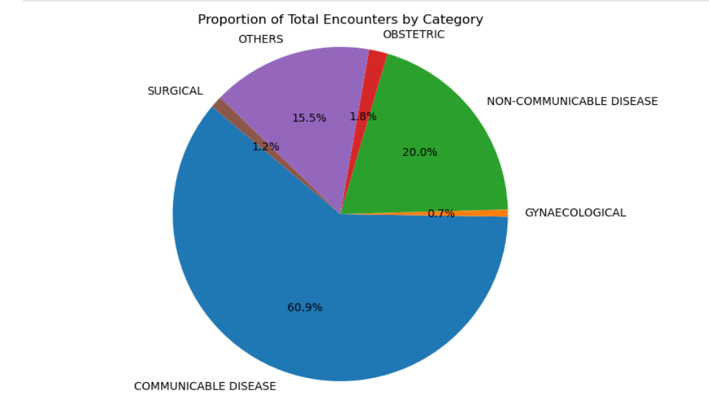

Key insights:

* Communicable disease holds the largest percentage in terms of encounters specifically driven by malaria.
* Non-communicable disease are also significant, with hypertension and diabetes leading the encounters.
* Other conditions who do not fall into any of the category above have a percentage of 15%
* Obstetric cases hold a significantly higher percentage of cases compared to Gynaecological cases.

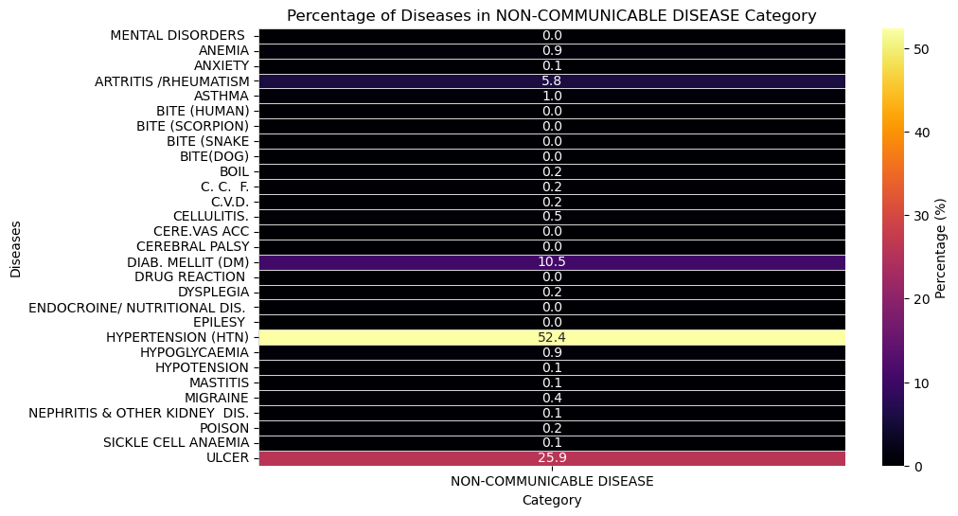

**Key Insights:**

* As earlier stated Hypertension leads the encounters for non-communicable diseases with 52.4%.
* Followed by Ulcer with 25.9%.
* Diabetes mellitus also hold a significant percentage with 10.5%

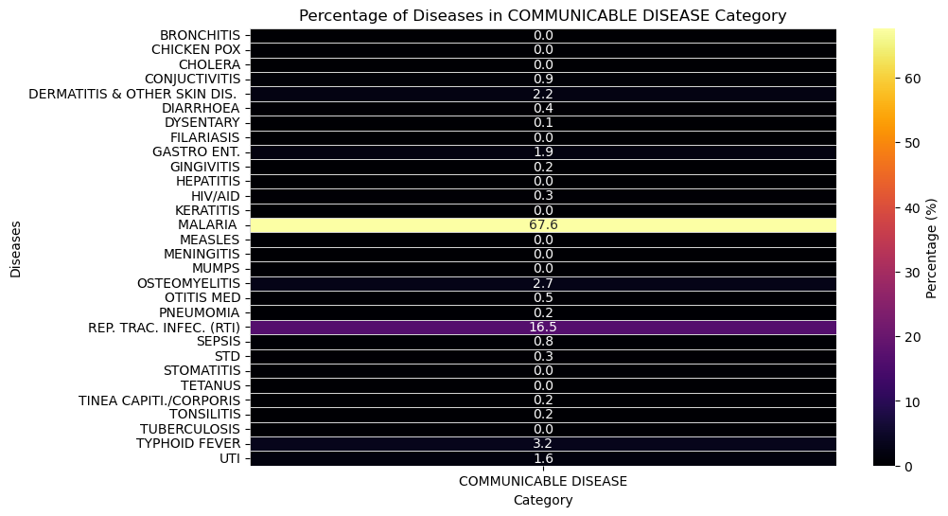

**KEY INSIGHTS:**

* Malaria holds the highest percentage of communicable disease with 67.6%
* Followed by malaria is respiratory tract infections with 16.5%
* Typhoid fever, osteomyelitis, skin infections and UTI all hold a signiificant percentage of the total encounters for communicale diseases.

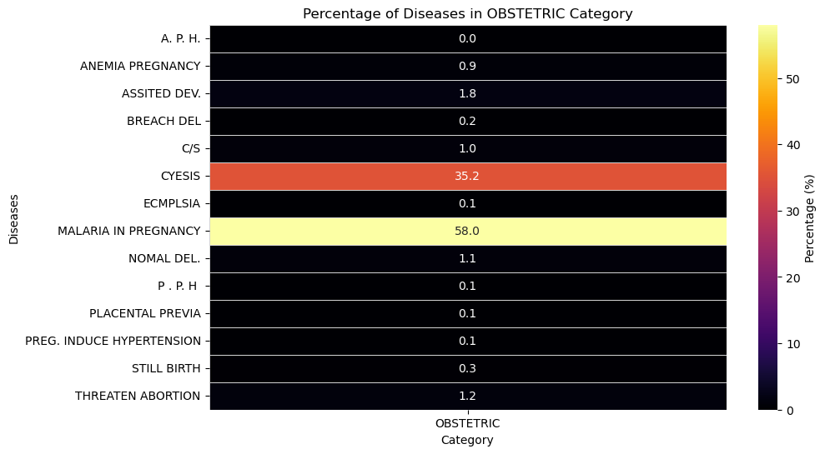

**KEY INSIGHTS**

* Malaria in pregnancy holds the highest share with 58%

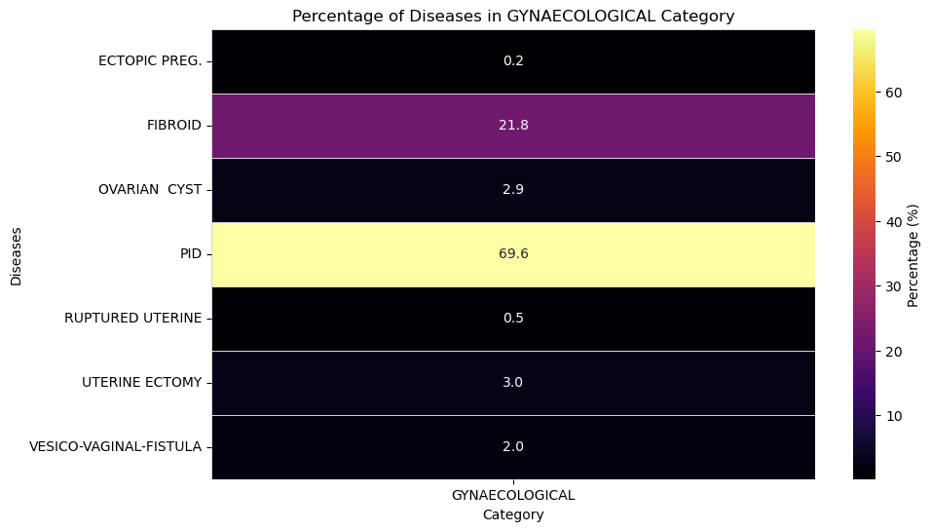

KEY INSIGHT:

* Pelvic inflammatory diseases holds the highest percentage of gynaecological cases followed by fibroid cases.

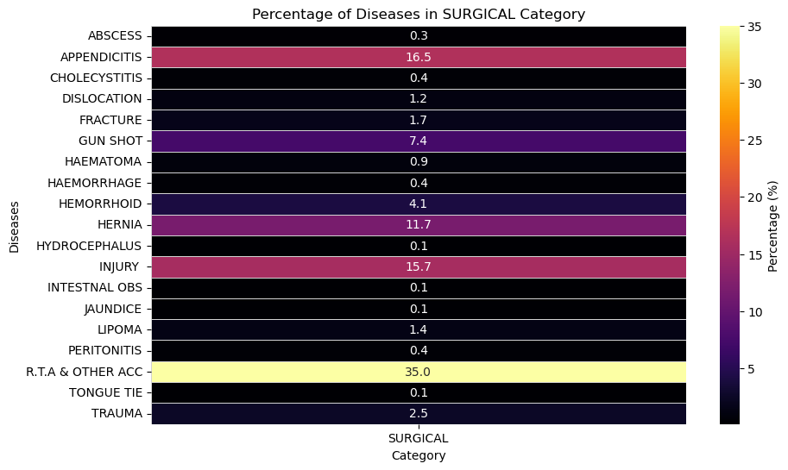

KEY INSIGHTS:

* RTA and other trauma related cases hold the highest percentages of the surgical cases.
* Followed by appendicitis which holds a percentage of 16.55%.
* Hernia also has a significant proportion of surgical cases with 11.7%.
* Hemorrhoids also hold a significant percentage with 4.1%.

